

CSCT Facilitator Guide Order Form

Please complete the form below and double-check all information for accuracy before sending.
Contact AHE at 312-422-3860 or CSCT@aha.org with any questions.

The fields listed are required – please print legibly
CSCT Trainer (T-CSCT) Name
Purchaser Name: |  |  | Member ID #
Title:
Facility Name:
Facility Address:
City, State, Zip Code:

Phone Number: | Fax Number: |  | E-mail

Facilitator Guide
◻ CSCT Facilitator Guide - $50.00 each  Product Code: 324CHESTFACILITATOR  ______ Number of Guides  ______ Payment Total  Price includes shipping | 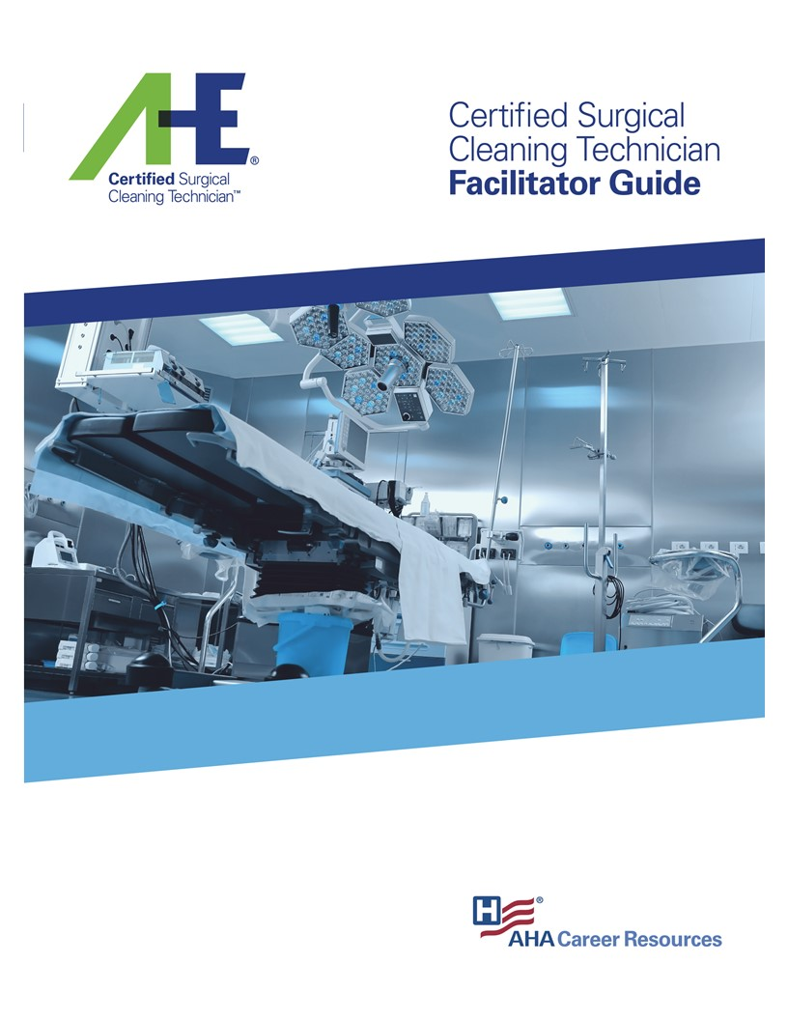

Payment Method

Please Invoice Me Credit Card Payment (If paying by credit card please check the box
and we will send you a secure link for payment)

Check is attached. Payable to: AHE
Mail to: AHE, P.O. Box 75315, Chicago, IL 60675
Fax to: 312-422-3609

